**Project Documentation**

PunchIO

Bendan Bernas

Pior

Elise Tan

Yuming Wu

# Manager login

* Manager login will allow employee to punch in/out
* Manager login will allow to view group
* Manager login will allow to view worked hours

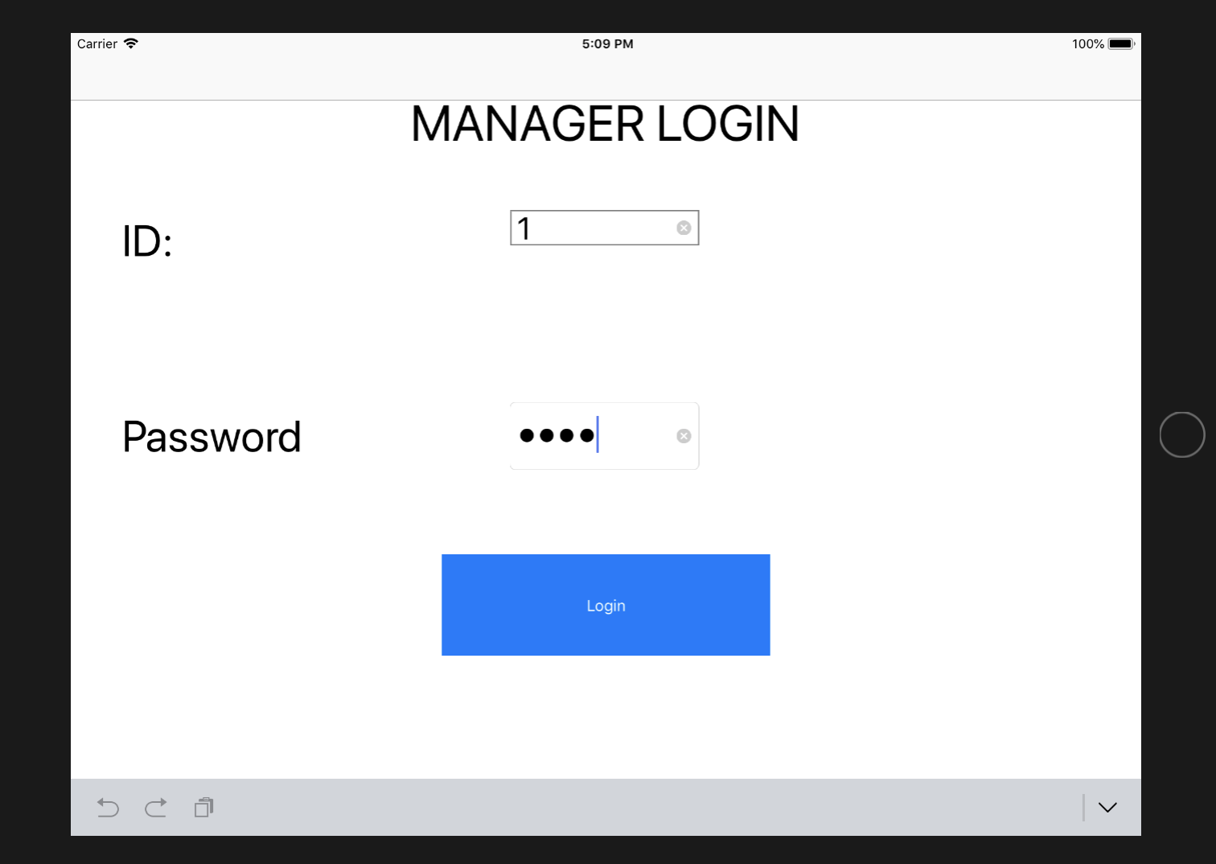

# Manager Login error

* If manager not use proper id or password error will show up

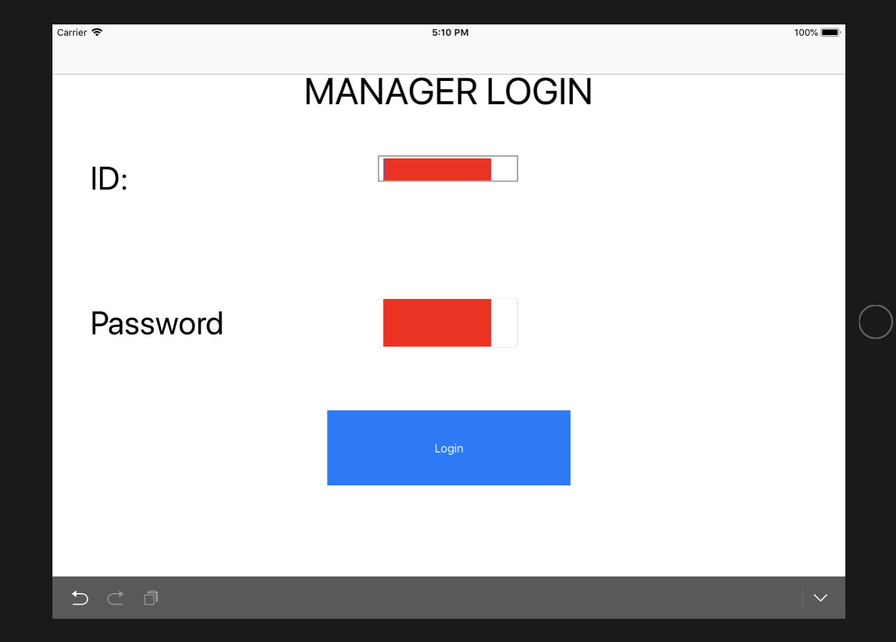

# View Group

* Groups the manager managing will show on this page
* From view group will be able continue to the employee sign in / punch in and out, also will be able to continue to view group work hours as well

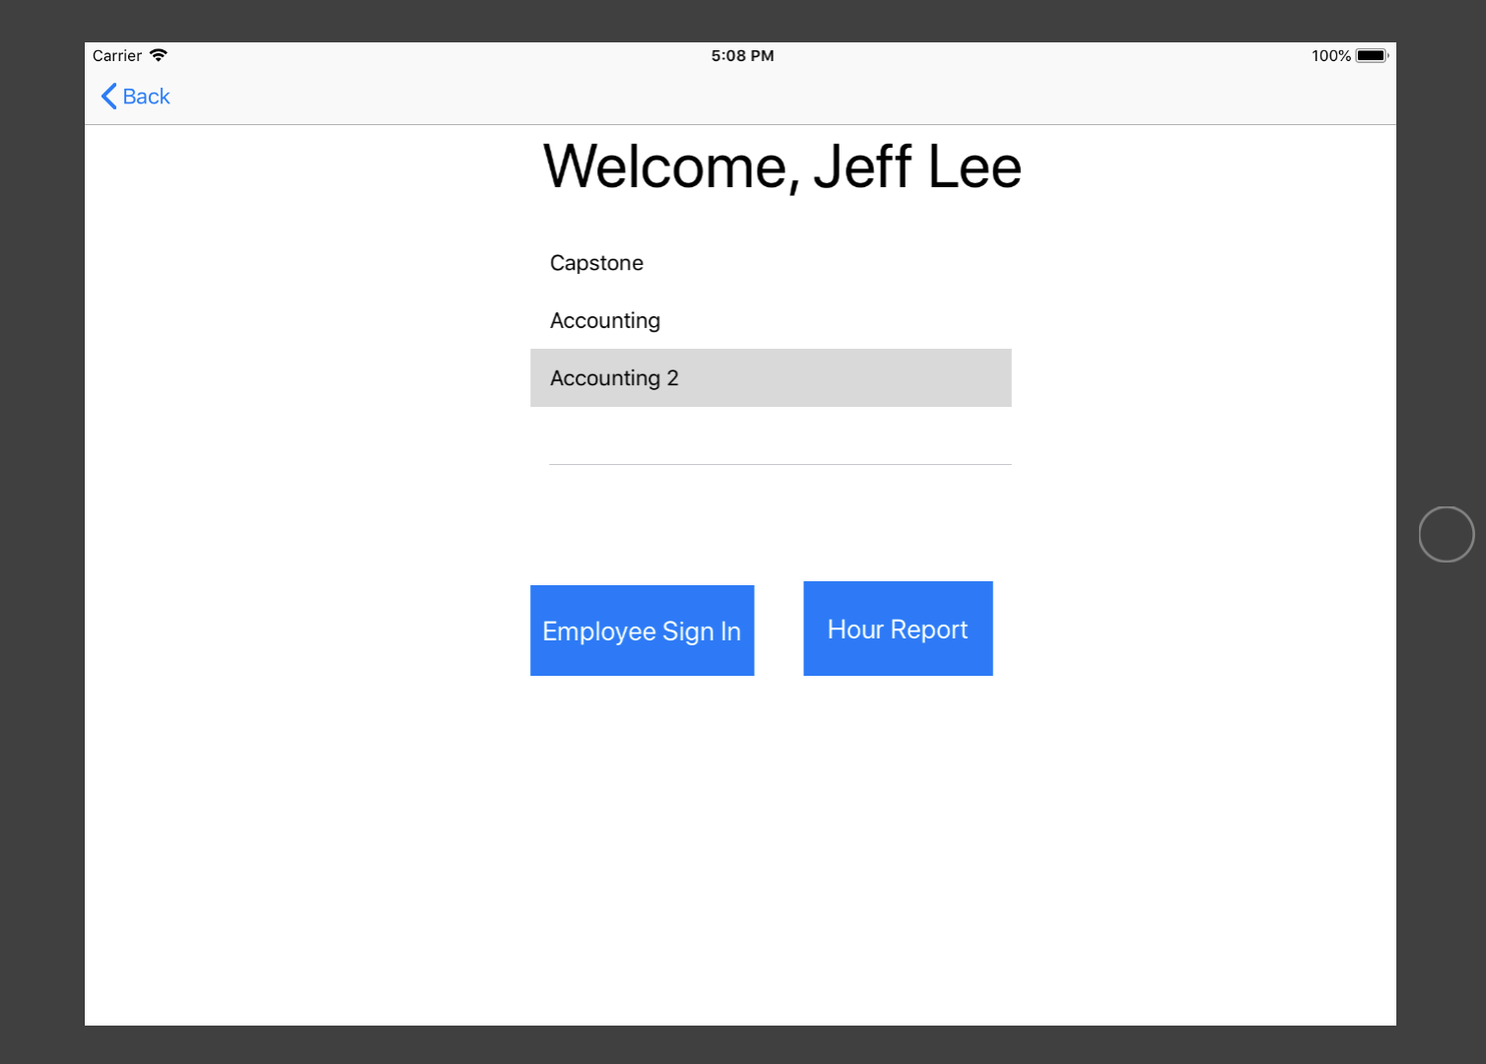

# Select Group

* To select group by click on the group name
* 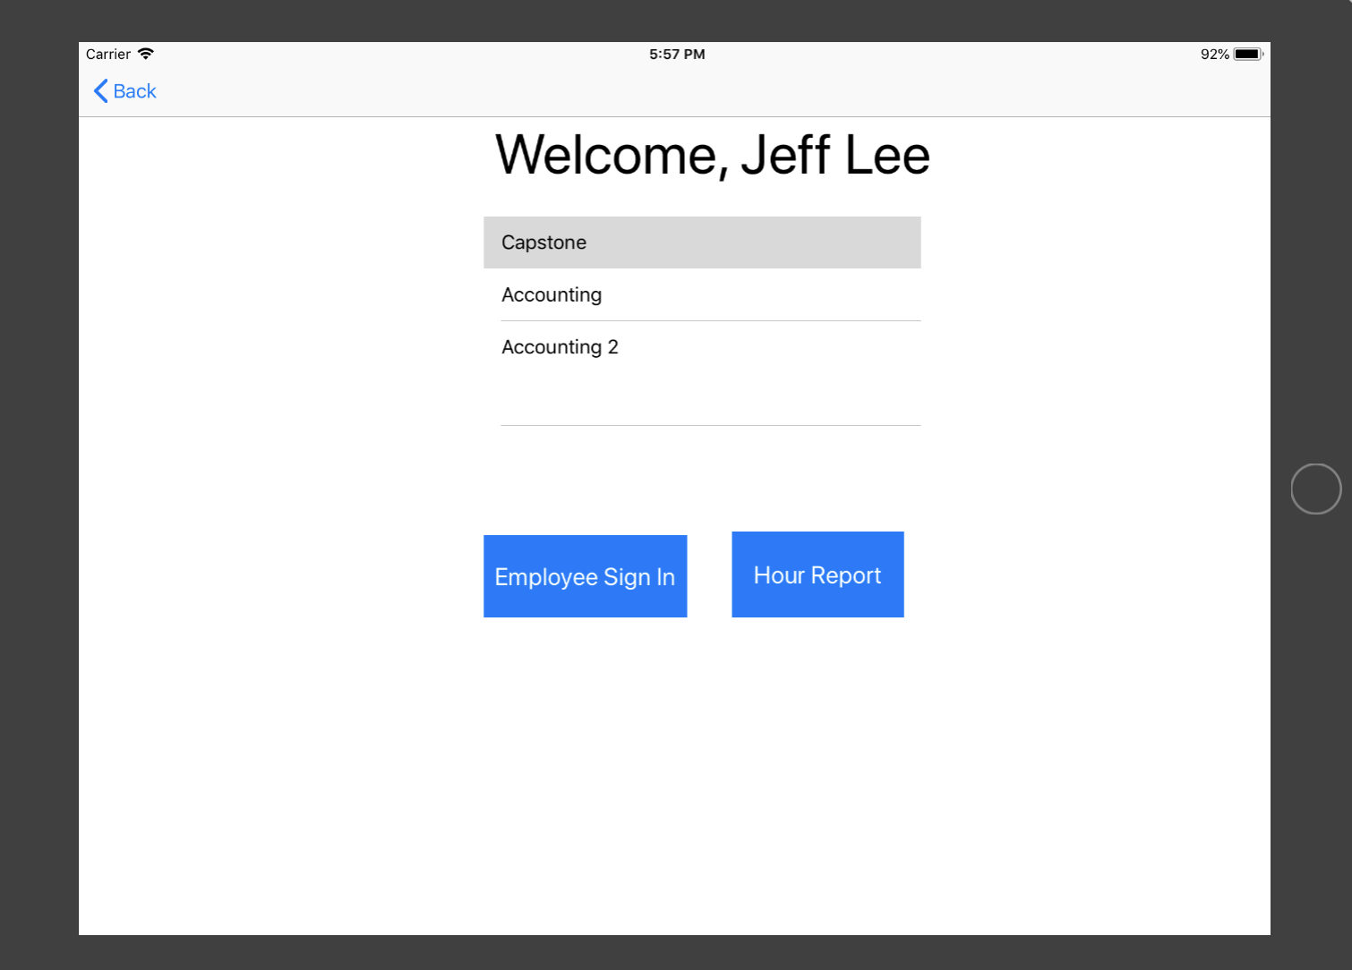Click on buttons go to specific pages

# Employee punch in

* After the Employee Login button clicked, the employee punch in/out page will show to the user
* By click on the employee name to select the specific employee to continue
  + 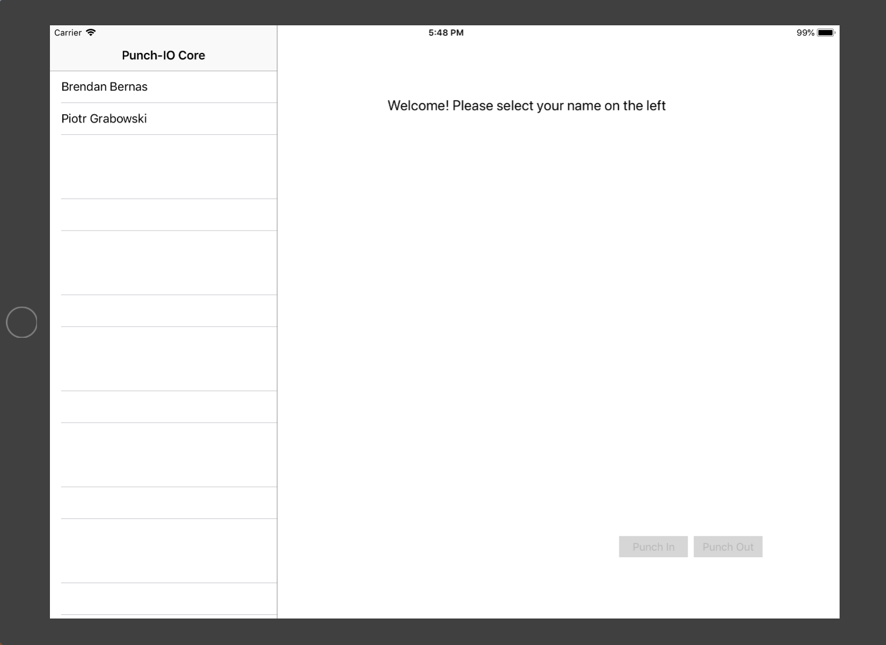If no employee selected the Punch In / Punch Out button will disable

# Employee work start

* After selected employee, Punch In button will be enable for the employee to punch in
* The Punch Out button will stay disable

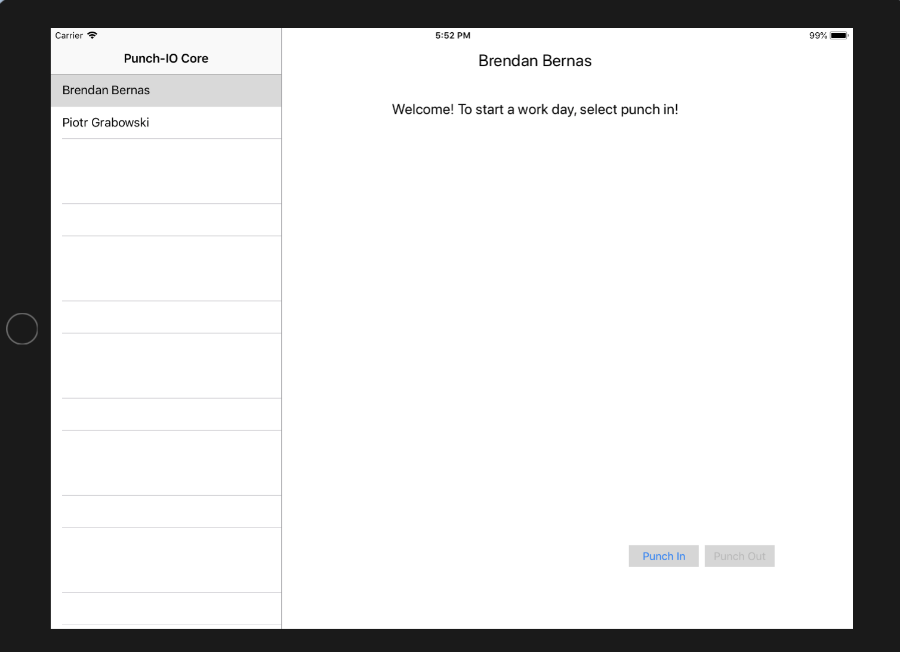

# Employee work count

* After the employee punch in, the start time will show on the screen
* The timer will start shows and runs
* The Punch In button disable
* The Punch Out button will ready for the employee to punch out

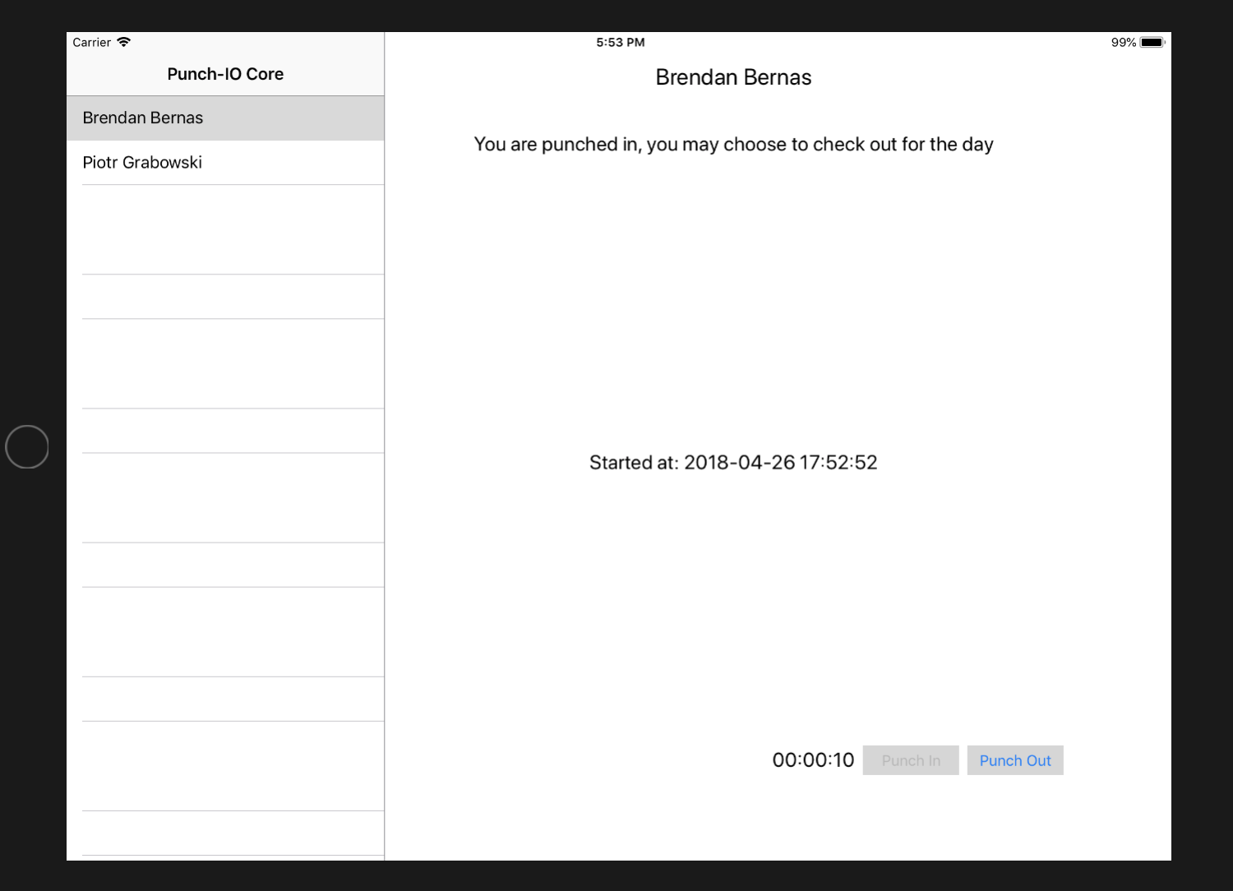

# Employee punch out

* After the employee punch out, the start time, end time and the length of the period work hours will appear on the screen
* The Punch In button enable again

# 

# View group hours

* 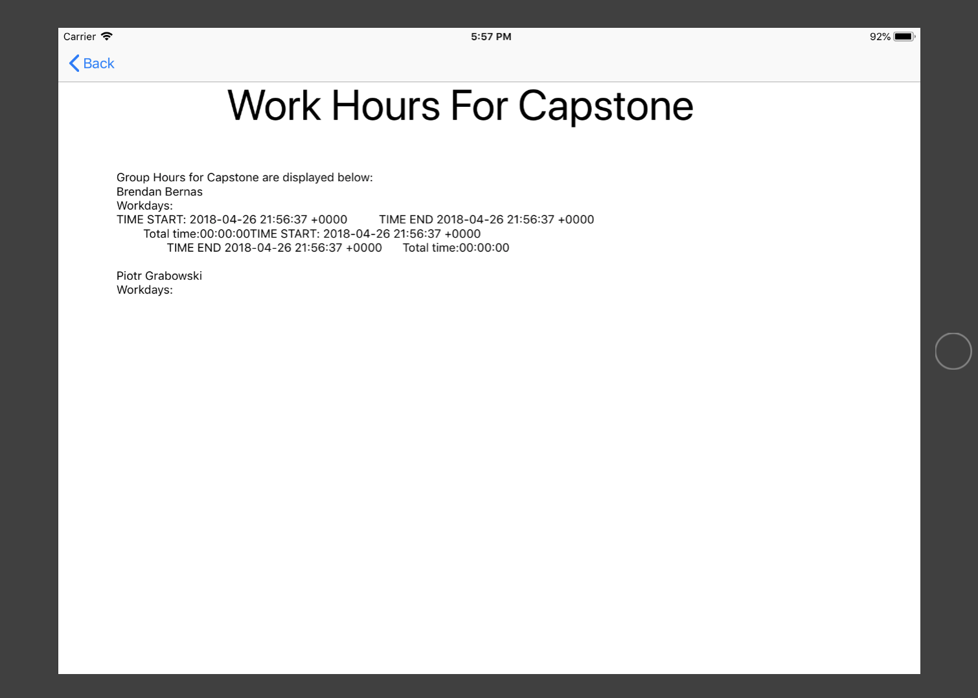After the Hour Report button clicked, all employees belong to this group will be show on the page